1. open GUI.m and run with matlab.

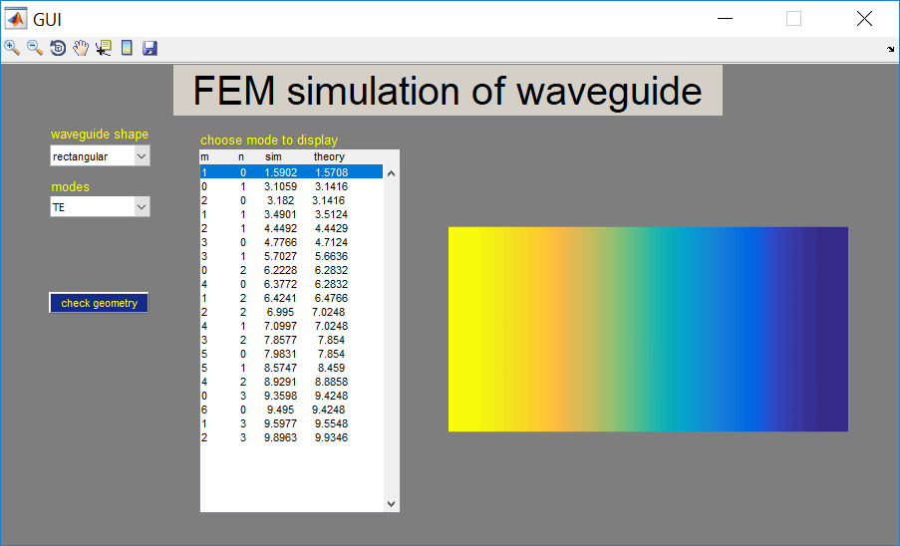

2. Select the ‘waveguide shape’, ‘modes’ and ‘choose mode to display’. The result figure will update automatically.

3. Use the toolbar on the upper-right corner of the GUI to use zoom in/zoom out/rotate/pan/data cursor/colorbar/save Figure.



4. click ‘check geometry’ button to display the subdomains of FEM.